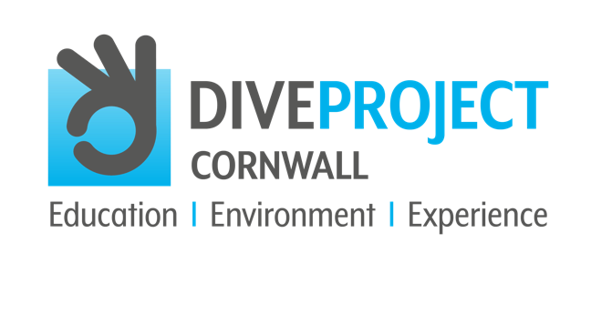

SEPTEMBER 2021
CONTACT: Andrew Forster, Project Director
TELEPHONE: 07711 160590
EMAIL: andy@diveprojectcornwall.co.uk
WEBSITE: www.diveprojectcornwall.co.uk

HAVE YOU GOT WHAT IT TAKES BE A
DIVE BUDDY SPONSOR WITH DIVE PROJECT CORNWALL?
In diving your Dive Buddy is your lifeline; it's who you rely on to ensure a fun and safe dive experience. DIVE PROJECT CORNWALL, the exciting new project to encourage teenagers to protect our oceans through diving, are looking for their own Dive Buddy Sponsors who can support one or more of the Lucky Teenagers to fully experience the benefits of DIVE PROJECT CORNWALL.

DIVE PROJECT CORNWALL will educate hundreds of thousands of young people by delivering an education programme directly into schools across the UK, raising awareness of the importance of the planet’s marine environment and its vital role in our very own existence.

GIVE A LUCKY TEENAGER THE OPPORTUNITY TO BECOME AN ‘OCEAN INFLUENCER’
As a Dive Buddy Sponsor, your contribution will help to give 400 lucky teenagers the opportunity of a lifetime, through participation in the PADI Open Water Diving qualification - a totally life changing experience; creating ‘Ocean Influencers' who will positively enrich, inspire and motivate the next generation to save our planet.

GET INVOLVED AND MAKE A DIFFERENCE
All DIVE PROJECT CORNWALL Dive Buddy’s will be invited to join the Welcome BBQ, giving you the opportunity to share your passion, enthusiasm and knowledge of the ocean with the lucky teenager you are sponsoring.

Dive Buddy sponsors will benefit from being part of a national campaign to deliver this message which will inform millions of adults and hundreds of thousands of young people across the UK.

If you think you’ve got what it takes to be a Dive Buddy Sponsor, register your details at www.diveprojectcornwall.co.uk or email Andrew Forster, Project Director at andy@diveprojectcornwall.co.uk Tel: 07711 160590

# # #

About DIVE PROJECT CORNWALL
Dive Project Cornwall is a new and exciting, not-for-profit community interest company and is the inspiration of Andrew Forster, CEO and Founder of Leven Media Group. Having moved his family to Cornwall from Bath, Andrew’s passion for marine conservation along with scuba-diving developed and he soon realised how lucky he was to be able to have this experience, whilst recognising that many others will never get the chance.

Now, as a PADI-certified Dive Master, Andrew is fortunate to spend part of his week volunteering on organised dive outings with the team at Kennack Diving and Porthkerris, Cornwall. Andrew owes his developed knowledge, understanding and wider appreciation for the beauty of marine life and the threats to its survival to everybody at Kennack Diving and Porthkerris. The connection between scuba-diving and ocean conservation has never been more evident.

Andrew now wants to give this amazing once-in-a-lifetime opportunity to 400 lucky teenagers from across the UK so they can become Ocean Influencers who will act to positively engage, inspire and motivate the next generation to save our planet.

Andrew’s aim is that through DIVE PROJECT CORNWALL we can shout loudly together to spread the message about the critical importance of the health of our oceans and educate people about the real and serious threats to our marine environment and the survival of our entire planet.

DIVE PROJECT CORNWALL are looking for Project sponsors and partners to join the campaign to eliminate plastic pollution and protect the marine environment to save all life in our oceans for many future generations to enjoy and cherish.
www.diveprojectcornwall.co.uk

About PADI
PADI® (Professional Association of Diving Instructors®) is the world’s largest ocean exploration and diver organization, operating in 186 countries and territories, with a global network of more than 6,600 dive centers and resorts and over 128,000 professional members worldwide. Issuing more than 1 million certifications each year, and with over 28 million certifications to date, PADI enables people around the world to seek adventure and save the ocean through underwater education, life-changing experiences and travel.

For over 50 years, PADI is undeniably The Way the World Learns to Dive®, maintaining its high standards for dive training, safety and customer service, monitored for worldwide consistency and quality. With a longstanding commitment to environmental conservation, PADI is leading the way for millions of people to actively explore, steward and protect the ocean through its course offerings and partnerships with like-minded, mission-driven organizations. PADI embodies a global commitment to ocean health with its mission to create a billion torchbearers to explore and protect the ocean.
Seek Adventure. Save the Ocean.SM
www.padi.com

