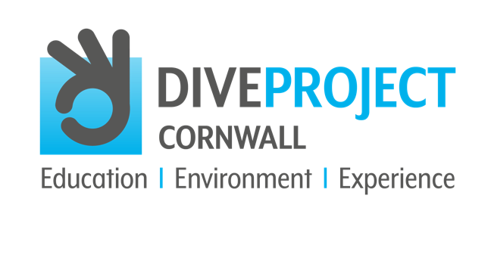

OCTOBER 2021
CONTACT: Andrew Forster, Project Director
TELEPHONE: 07711 160590
EMAIL: andy@diveprojectcornwall.co.uk
WEBSITE: www.diveprojectcornwall.co.uk

Atlantic Puffin
Fratercula artica

The Atlantic Puffin is an iconic species easily identifiable in the summer months by its black and white feathers, brightly coloured beak and orange legs.

Did you know that the Atlantic Puffin can flap their wings up to 400 times per minute and reach flying speeds of 55 miles an hour?

We’re all familiar with the penguin-like black and white colouring and brilliantly vibrant beak and legs of the Atlantic Puffin, although many of us won’t yet have seen one in the wild, and as the species is now on the Red list of conservation concern, and are listed as ‘vulnerable’ on the global IUCN Red List of Threatened Species, our chances of seeing this stunning bird grow slimmer all the time.

Frequentists of the north Cornish coast, the Bempton Cliffs in Yorkshire and many places in Wales, Northern Ireland and Scotland, Atlantic Puffins spend their winter days at sea, resting on the waves and diving for fish. Much better equipped for a life at sea than on land, the Atlantic Puffin is an excellent swimmer, using their wings to ‘fly’ underwater, steering with rudder-like feet and diving to depths of 200 feet in search of small fish like herring or sand eels, although they’ll usually only remain underwater for 20 to 30 seconds.

When winter turns to spring, the puffins land on north Atlantic sea coasts and islands to form breeding colonies, and during this time their previously grey beaks will transform into a vibrant orange, an image we’re more familiar with. Prior to the breeding period, the adult birds return to their previously established colonies, but spend most of their time on the sea in large flocks known as 'rafts'.

When breeding season comes around, the birds will often select precipitous, rocky cliff tops to build their nests, which they line with feathers or grass. Females lay a single egg, and both parents take turns incubating it. When a chick hatches, the parents take turns to hunt for food and return to feed them, and it seems that puffin couples often reunite at the same burrow site each year. No one knows for sure how these birds find their way back to their home grounds after months at sea, whether it’s by using visual reference points, smells, sounds, the Earth’s magnetic field, or perhaps even the stars.

Get involved and make a difference – support DIVE PROJECT CORNWALL in their vision to eliminate plastic pollution and protect the marine environment, to save all life in our oceans for future generations to enjoy and cherish.

USEFUL HASHTAGS FOR SOCIAL MEDIA AND DIVE PROJECT CORNWALL
#divecornwall #diveprojectcornwall #divelocal #scubadive #scuba #cornwall #padi #lovecornwall #cornwalllife #cornwallliving #cornwall-living #mcsuk #getinvolved #makeadifference #marineconservation #oceanconservation #oceaninfluencer #400luckyteenagers #divebuddy #protectouroceans #saveouroceans #scubadiving #divesafe #divinglife #stopplasticpollution #saynotoplastic #stopplasticpollution #iftheseadiessodowe #missionblue #nobluenogreen #ocean #oceanlife #education_environment_experience #inform_awareness_understand #protect_sustainable_eliminate #saveouroceans #oceaneducation #marinelifeeducation #oceanconservation #marineconservation #oceaninfluencer #diver #dive #makeadifference #protectouroceans #supportdiveprojectcornwall #saveouroceans #oceaneducation #marinelifeeducation #oceanconservation #marineconservation #saveourseas #marineconservationsociety #dive #dive #cornwall #divebuddy #opportunity_learn_inspire

