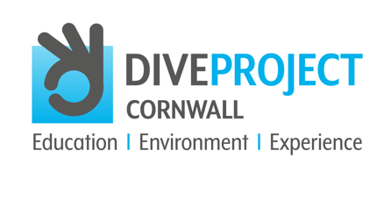
May 11th 2022

DIVE PROJECT CORNWALL ANNOUNCES
NEW SPONSOR, WATERHAUL

Dive Project Cornwall continues to take pace and has now engaged 259 secondary schools across the UK. The project which offers learning resources to schools to educate young people about the importance of the ocean estimate their education programme has now reached over 250,000 pupils.

The project, which is a not-for-profit community interest company was launched on the 8th of June 2022 (World Ocean Day) and has since raise over £180,000 to deliver the educational tools to schools. At the heart of the project is a competition for 20 schools to win a place for 20 of their students to take enjoy life-changing trip to experience the ocean and learn to scuba dive (20 schools, each bring 20 young people = 400 young people).

On hearing of the project plastic-recycled-material manufacturer and new brand Waterhaul just had to get involved. Striking a new sponsorship deal around their sunglass range Gavin Parker, Co-founder and COO said...

"We're really proud to be supporting Dive Project Cornwall and their amazing efforts to offer young people a chance to immerse themselves in the ocean, and learn about the importance of the marine environment. Myself and Harry (Waterhaul's CEO) have backgrounds in marine conservation and are divers ourselves. Therefore, we fully understand how this is not just an incredibly exciting programme for these teenagers, but also a crucial opportunity to educate the younger generation about the threats faced by marine life, and how they can support conservation efforts to preserve it for future generations" - Gavin Parker (Co-founder and COO)

For more information on the Waterhaul range of sunglasses - made from ghost nets found on our beaches - https://waterhaul.co/
If you are interested to become a stockist contact Kieran Hill - kieran@waterhaul.co

[For more copy about Waterhaul - https://waterhaul.co/pages/aboutus]

Dive Project Cornwall’s Project Director Andy Forster said…

“It’s brilliant to find another business that get’s what we are doing - and Waterhaul certainly get it. Our desire to educate the future generation as to the part the ocean plays in our very own existence is so important. Thanks to Kieran, Gavin and Harry for getting on board and helping us to do just that whilst providing an amazing oppportunity to 400 young people”

Dive Project Cornwall continues to drive to it’s funding goal with all of its support coming through sponsorships from businesses and individuals that genuinely care about EDUCATION ENVIRONMENT and EXPERIENCE.

GET INVOLVED and MAKE A DIFFERENCE - contact Andy on andy@diveprojectcornwall.co.uk or call on 07711 160590

