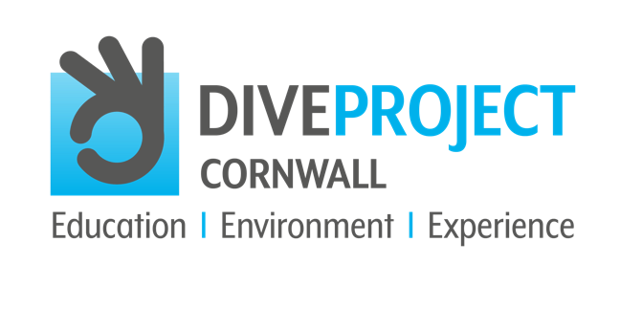

AUGUST 2021
CONTACT: Andrew Forster, Project Director
TELEPHONE: 07711 160590
EMAIL: andy@diveprojectcornwall.co.uk
WEBSITE: www.diveprojectcornwall.co.uk

Cuttlefish
Sepia officinalis

The largest cuttlefish found in UK seas, and a close cousin of squids and octopuses.

You may have seen the creamy internal shells of the cuttlefish strewn across the beaches that border our little island of Britain, chalky to the touch and known as cuttlebones to many. Before washing onto our shores in this form, the cuttlefish looks much like a squid, darting around in depths of up to 200 metres in the cool Atlantic water.

Did you know that the cuttlefish will often bury itself in the sandy seabed to hide from predators, leaving only its eyes exposed?

You may not know that the common cuttlefish is a fierce predator, making light work of crabs, fish and even smaller cuttlefish! Their mouths with beak-like jaws are no match for any crustacean they might take a liking to, and their well-developed head and large eyes give them a stern and intelligent expression as they prowl the depths. They sport a fin that runs around the length of their body, along with eight anterior arms lined with suckers, plus two extendable tentacles around the mouth, which can shoot out to catch prey.

Cuttlefish tend to be rather unique with each one varying in colour, but they’re normally a blackish-brown with a mottled or striped pattern. However, when it comes to breeding in the spring, the cuttlefish will make their way to shallow waters, and this is where the male of the species comes alive, engaging in spectacular displays of pulsing colours along their bodies to attract a female. This ability also comes in handy when they need to disappear into the background if danger is near, or if they’d prefer to distract a predator.

After breeding, cuttlefish eggs are dyed black with their ink, and it’s easy to understand why they’re often referred to as ‘sea grapes’. Cuttlefish usually only live for two years, and will die after breeding and passing on their genes successfully, making way for the next generation.

Get involved and make a difference – support DIVE PROJECT CORNWALL in their vision to eliminate plastic pollution and protect the marine environment, to save all life in our oceans for future generations to enjoy and cherish.

USEFUL HASHTAGS FOR SOCIAL MEDIA AND DIVE PROJECT CORNWALL
#divecornwall #diveprojectcornwall #divelocal #scubadive #scuba #cornwall #padi #lovecornwall #cornwalllife #cornwallliving #cornwall-living #mcsuk #getinvolved #makeadifference #marineconservation #oceanconservation #oceaninfluencer #400luckyteenagers #divebuddy #protectouroceans #saveouroceans #scubadiving #divesafe #divinglife #stopplasticpollution #saynotoplastic #stopplasticpollution #iftheseadiessodowe #missionblue #nobluenogreen #ocean #oceanlife #education_environment_experience #inform_awareness_understand #protect_sustainable_eliminate #saveouroceans #oceaneducation #marinelifeeducation #oceanconservation #marineconservation #oceaninfluencer #diver #dive #makeadifference #protectouroceans #supportdiveprojectcornwall #saveouroceans #oceaneducation #marinelifeeducation #oceanconservation #marineconservation #saveourseas #marineconservationsociety #dive #dive #cornwall #divebuddy #opportunity_learn_inspire

