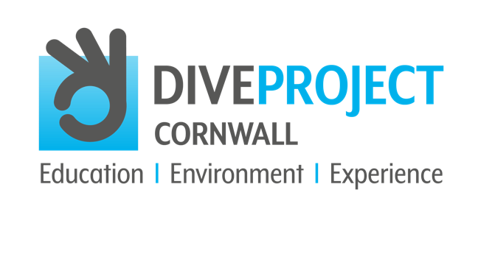

SEPTEMBER 2021
CONTACT: Andrew Forster, Project Director
TELEPHONE: 07711 160590
EMAIL: andy@diveprojectcornwall.co.uk
WEBSITE: www.diveprojectcornwall.co.uk

An estimated truckload of rubbish is dumped into our oceans every minute
When we think of the ocean, green-blue ideals of sparkling waters and vibrant sea life thriving in their underwater paradise spring to mind – the ocean as it should be. But is this optimistic reality slipping away from us as we continue to live the way that we do?

Alongside bubble-gum pink jellyfish float the sinister imitation of ghostly plastic bags, the only kind of marine life that our future generations can expect to see if we continue on this devastating trajectory. A study undertaken by the World Economic Forum, the Ellen MacArthur Foundation and McKinsey and Company showed the scale of what we’re facing in the global plastic system. A full 32% of the 78 million tons of plastic packaging produced annually is left to flow into our oceans; the equivalent of pouring one huge truck of plastic into the ocean every minute.

This rate isn’t looking to slow, with an expectation of this increasing to two truck-loads per minute by 2030, and four per minute by 2050. By then, there will be more plastic in the world’s oceans than fish, which is a frightening prospect that we may never be able to recover from.

There are small rays of hope on the horizon, however, one of which is The Ocean Cleanup – a start-up founded in 2013 by Boyan Slat, which aims to try and clear 70 million kilograms of plastic out of the Great Pacific Garbage Patch in 10 years, an absolutely colossal feat. The company plans to use a large array that will be anchored to the bottom of the Pacific ocean, with arms that spread out over 100km to capture all of the plastic debris pushed into its nets by the ocean’s currents. This is then collected by a giant container with a 10,000-metre-cubed capacity that will be emptied monthly. As it says on the company website, “Why move through the ocean, if the ocean can move through you?”

Get involved and make a difference – support DIVE PROJECT CORNWALL in their vision to eliminate plastic pollution and protect the marine environment, to save all life in our oceans for future generations to enjoy and cherish.

USEFUL HASHTAGS FOR SOCIAL MEDIA AND DIVE PROJECT CORNWALL
#divecornwall #diveprojectcornwall #divelocal #scubadive #scuba #cornwall #padi #lovecornwall #cornwalllife #cornwallliving #cornwall-living #mcsuk #getinvolved #makeadifference #marineconservation #oceanconservation #oceaninfluencer #400luckyteenagers #divebuddy #protectouroceans #saveouroceans #scubadiving #divesafe #divinglife #stopplasticpollution #saynotoplastic #stopplasticpollution #iftheseadiessodowe #missionblue #nobluenogreen #ocean #oceanlife #education_environment_experience #inform_awareness_understand #protect_sustainable_eliminate #saveouroceans #oceaneducation #marinelifeeducation #oceanconservation #marineconservation #oceaninfluencer #diver #dive #makeadifference #protectouroceans #supportdiveprojectcornwall #saveouroceans #oceaneducation #marinelifeeducation #oceanconservation #marineconservation #saveourseas #marineconservationsociety #dive #dive #cornwall #divebuddy #opportunity_learn_inspire

