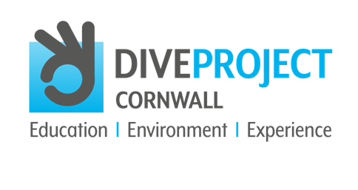
SOCIAL CONTENT EDUCATION

Please use the following content across your social channels with the suggested hashtags. For reference DIVE PROJECT CORNWALL is on the following channels:
Twitter @thediveproject Instagram @diveprojectcornwall

We also invite you to follow DIVE PROJECT CORNWALL on Facebook.

We would be grateful if you could use the handles according to the channel being posted to.

DIVE PROJECT CORNWALL’s mission concentrates on three principles: EDUCATION, ENVIRONMENT and EXPERIENCE. With this focus, we have the chance to protect our oceans for future generations to enjoy. Find out how you can get involved with DIVE PROJECT CORNWALL and help them reach their goals https://bit.ly/2StKFNm

#saveouroceans #oceaneducation #marinelifeeducation #oceanconservation #marineconservation #oceaninfluencer #diver #dive #makeadifference #protectouroceans #supportdiveprojectcornwall #saveouroceans #oceaneducation #marinelifeeducation #oceanconservation #marineconservation #saveourseas #marineconservationsociety #dive #diver #makeadifference #stoptheplasticide #openwaterdiving #oceanpollution #plasticpollution

[Your organisation] is/are proud to be partnering with DIVE PROJECT CORNWALL in their mission to inform and raise awareness of the importance of our oceans, enabling greater understanding of how we can all play a part in ocean conservation. https://bit.ly/3viLHt1

#protectwhatyoulove #oceanminded #diving #oceaninfluencer #oceaneducation #marinelifeeducation #oceanconservation #marineconservation #diver #dive #climatecrisis #stoptheplasticide #marineconservationsociety #oceaneducation #plasticpollution #diving #scubadiving #openwaterdiving #padi #oceaninfluencer #diver #dive #makeadifference

[Your organisation] is/are working with DIVE PROJECT CORNWALL to INFORM hundreds of thousands of young people and millions of adults as to the importance of our oceans through education and experience https://bit.ly/3viLHt1

#protectwhatyoulove #oceanminded #diving #oceaninfluencer #oceaneducation #marinelifeeducation #oceanconservation #marineconservation #diver #dive #climatecrisis #stoptheplasticide #marineconservationsociety #makeadifference

Become a #DIVEBUDDY and help DIVE PROJECT CORNWALL to raise AWARENESS of the impact that the ocean has on human life itself and how our very own existence depends on it https://bit.ly/2U4ZmXN

#protectouroceans #supportdiveprojectcornwall #saveouroceans #oceaneducation #marinelifeeducation #oceanconservation #marineconservation #saveourseas #plasticpollution #diving #scubadiving #openwaterdiving #padi #oceaninfluencer #diver #dive #marineconservationsociety #makeadifference
DIVE PROJECT CORNWALL will help 400 lucky teenagers UNDERSTAND that by supporting conservation everyone can all help to save the planet, wherever they live. Become a partner or project sponsor with DIVE PROJECT CORNWALL and make a difference https://bit.ly/3goatlW

#marineconservationsociety #padi #protectouroceans #supportdiveprojectcornwall #saveouroceans #oceaneducation #marinelifeeducation #oceanconservation #marineconservation #oceaninfluencer #diver #dive #makeadifference #400luckyteenagers #oceaninfluencer

